**COURSE: CLOUD AND NETWORK SECURITY _C1-2024**

**STUDENT NAME: LENNIE NTHIGA**

**STUDENT NO: cs-cns07-24170**

**WEEK 12 ASSIGNMENT 1**

**CLASS EXERCISE: EXAMINE TCP/IP AND OSI MODELS IN ACTION**

**Introduction**

From the flaws challenge will get to know common mistakes when using web services and how they can be exploited which would be vulnerable to xss attack and to ssrf attacks and more. Most of the challenges requiring one to find a sub directory to the next task.

**Level 1**

1. Finding out the domains of flaws. Cloud using dig

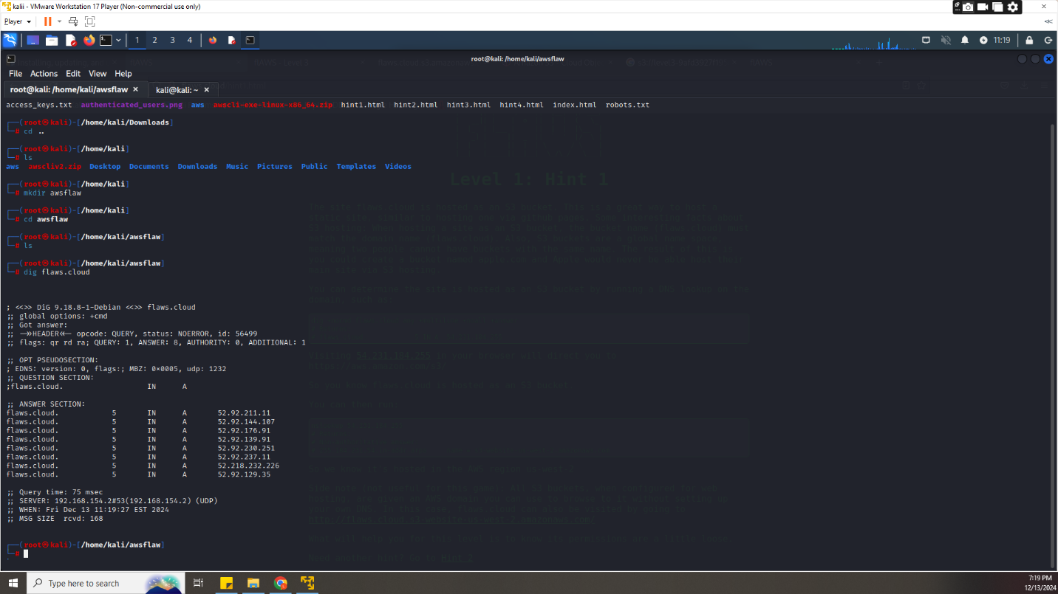

1. That Ip when run in browser it would open a was page

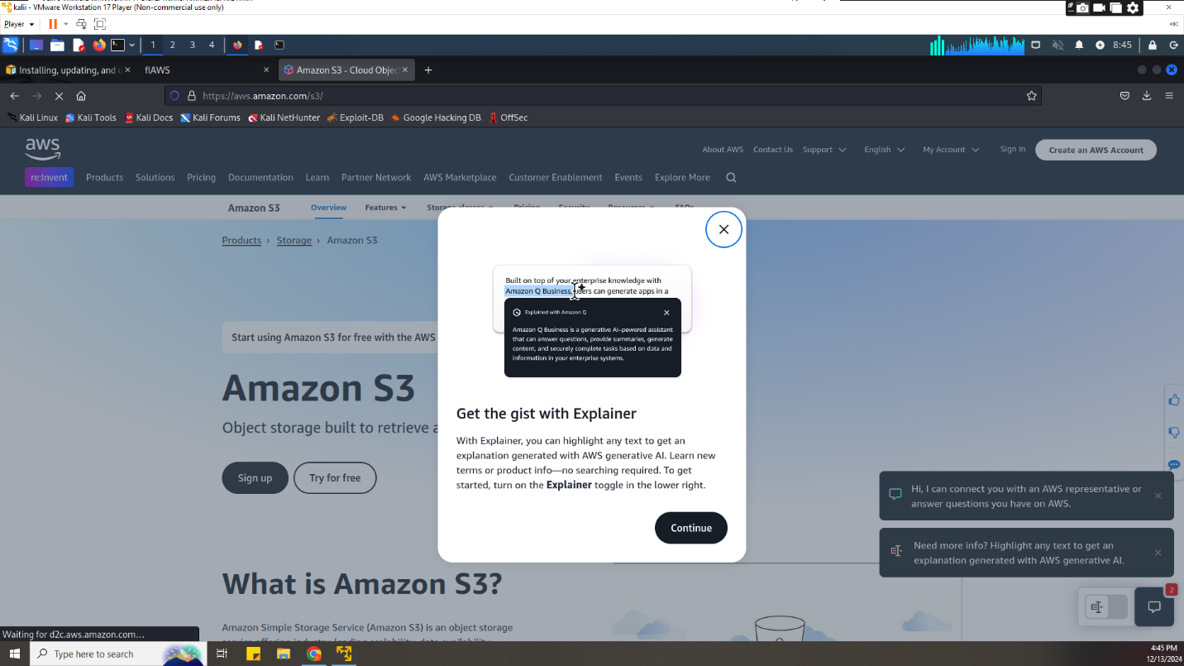

1. Using one of the is of flaws. Cloud we would try finding the domain name server of that Ip using nslookup which resulted to the finding of the region of the s3 bucket

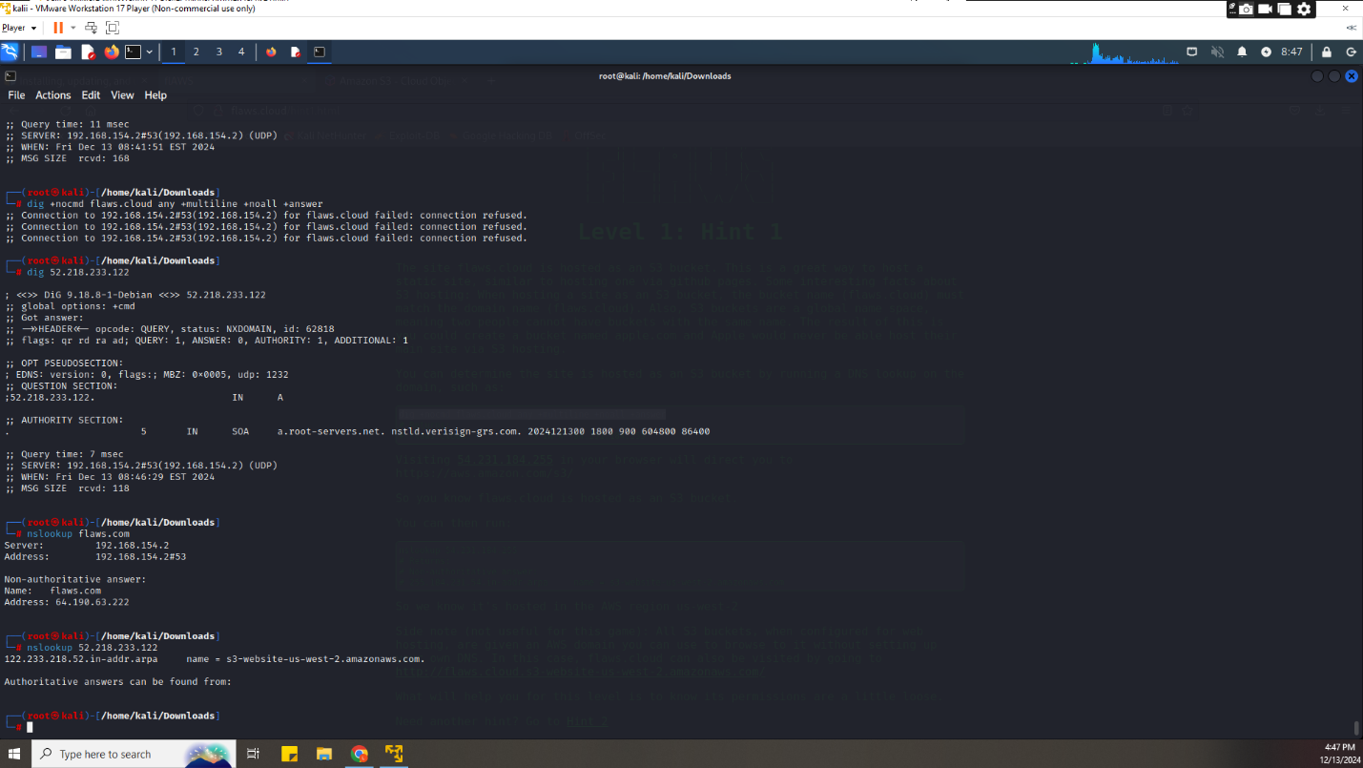

1. Using aws s3 ls s3://flaws.cloud/ --no-sign-request --region us-west-2 we would find thee list of objects or directories in the flaws. Cloud S3 bucket. In which had a secret file that when opened using curl it had a link to level 2

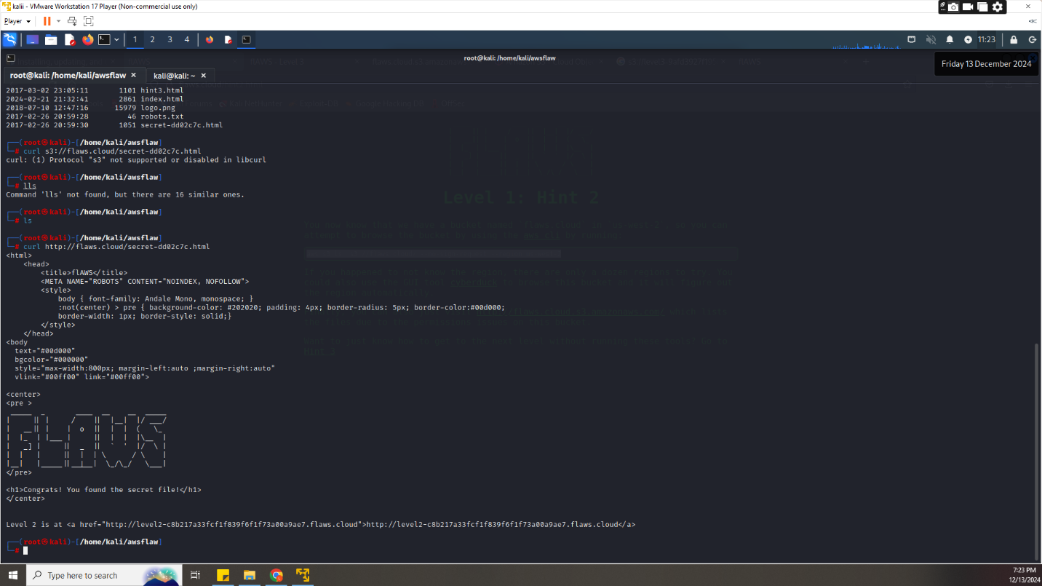

**Level 2**

1. Since we have the s3 bucket link to the next level we would list its objects and files which provided a 3rd link to level 3

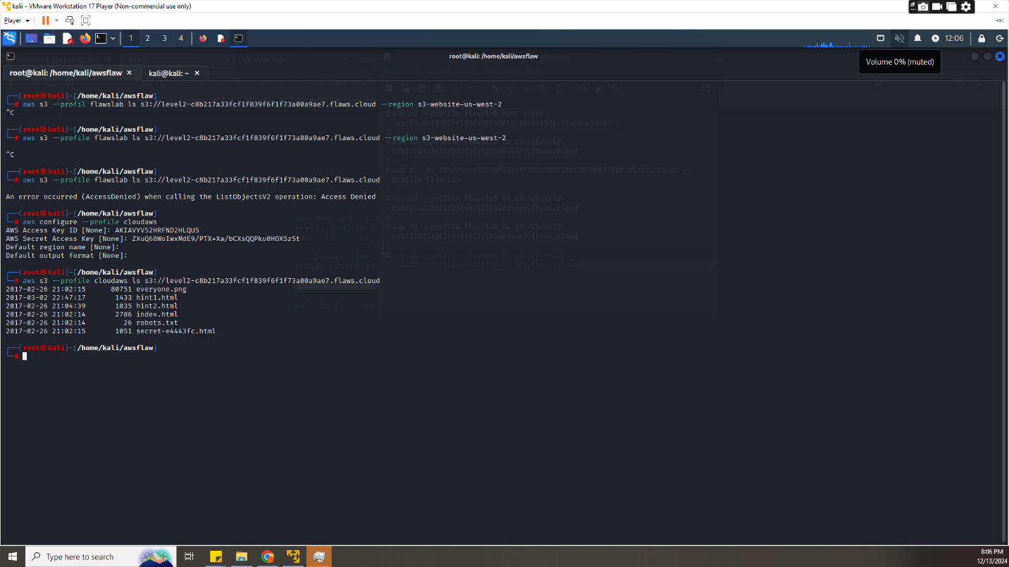

Level 3

1. Since we have Since we have the s3 bucket link to level3 we would list its objects

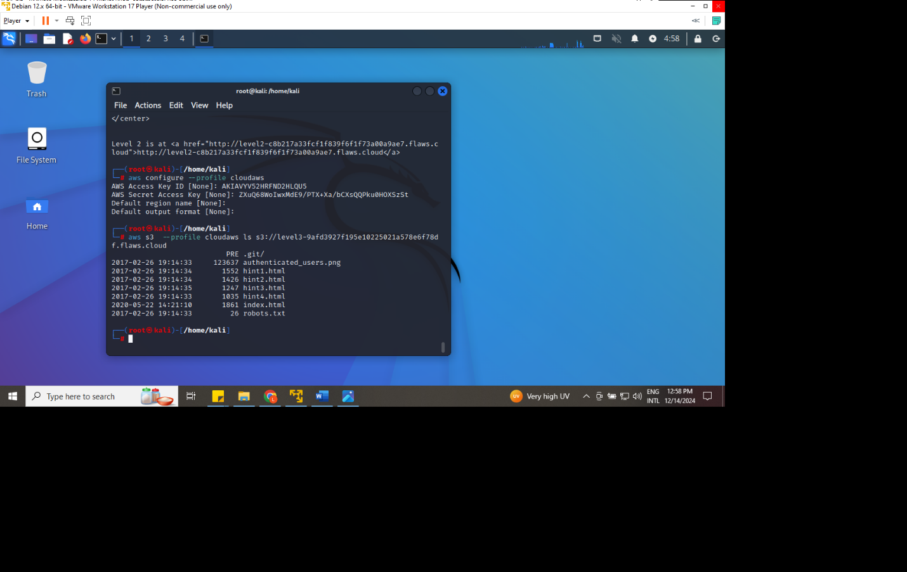

1. From the list of its contents there’s a git which we can download its repositories

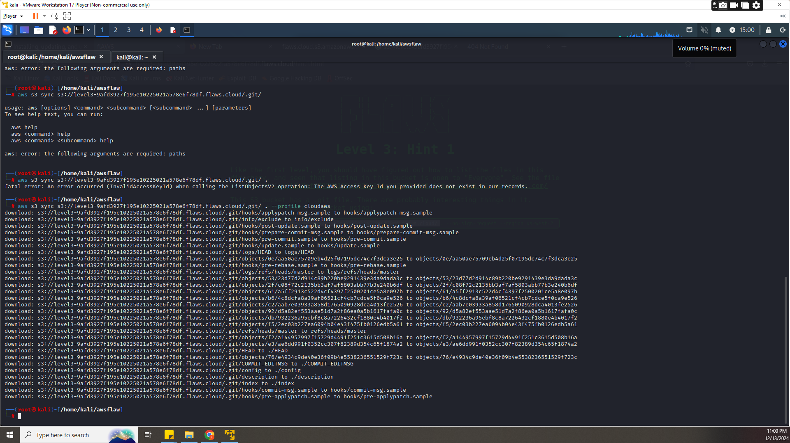

1. Now we can look up the logs of the git and check its contents whereby it listed access key and secret key of an was profile which we can configure to use in the next levels

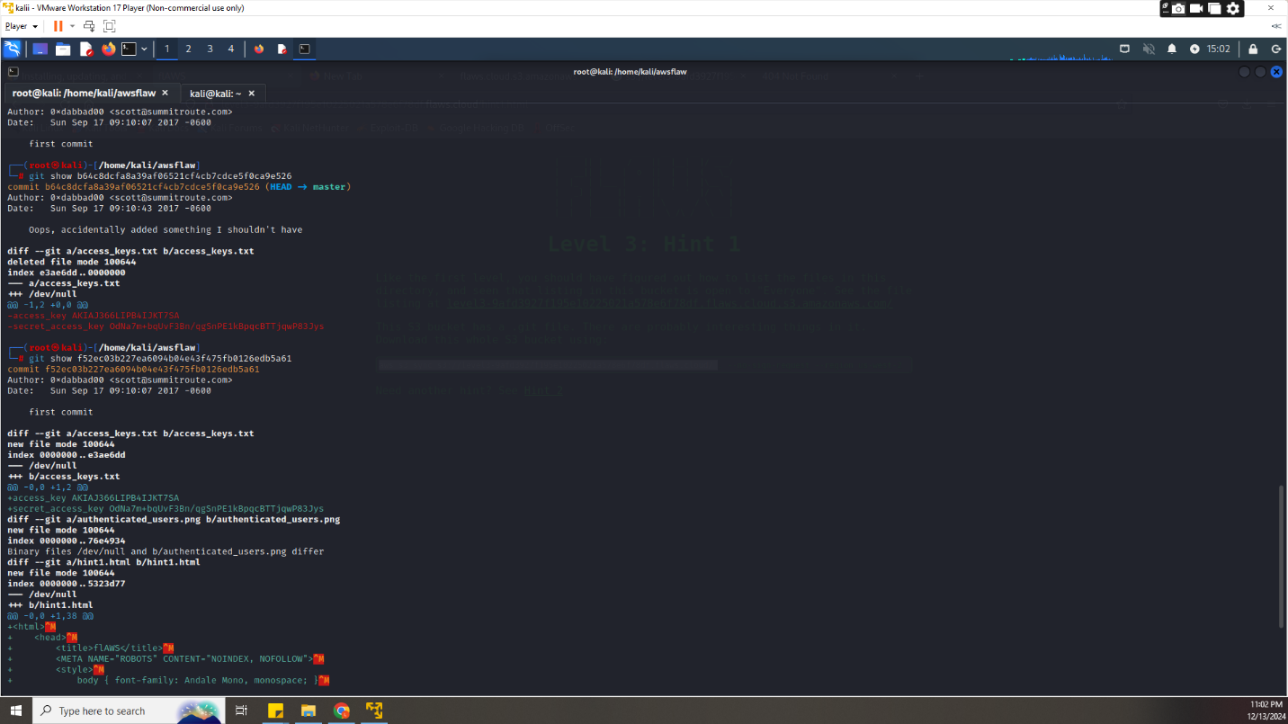

1. New aws profile Scott



1. From the new profile we can check its details of the profile which was found to be a backup user. we could also look at a snapshot of the disk volume of the Ec2 using **aws –profile scott ec2 describe-snapshots --owner-id 975426262029**

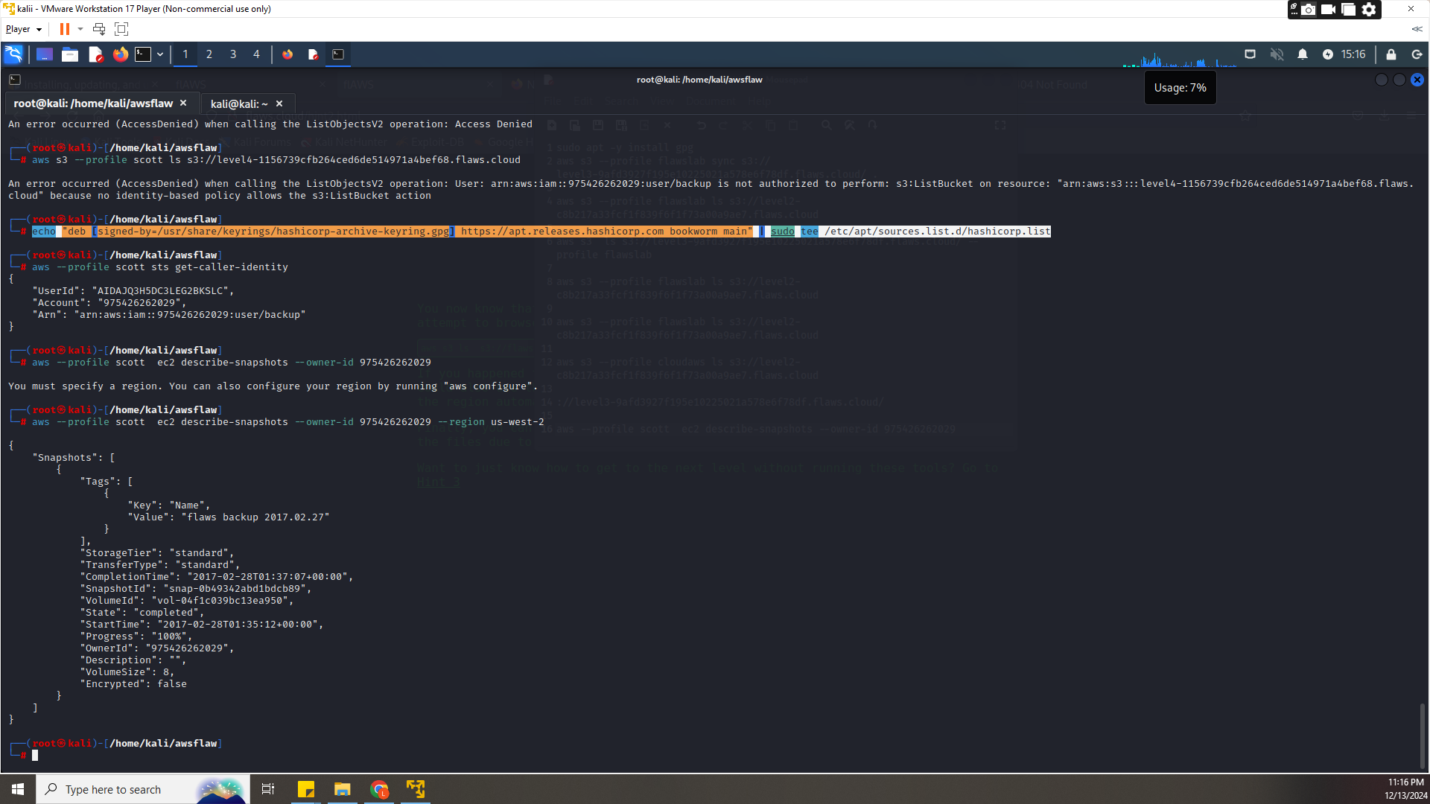

1. We would find out the snapshot it of scotts ec2

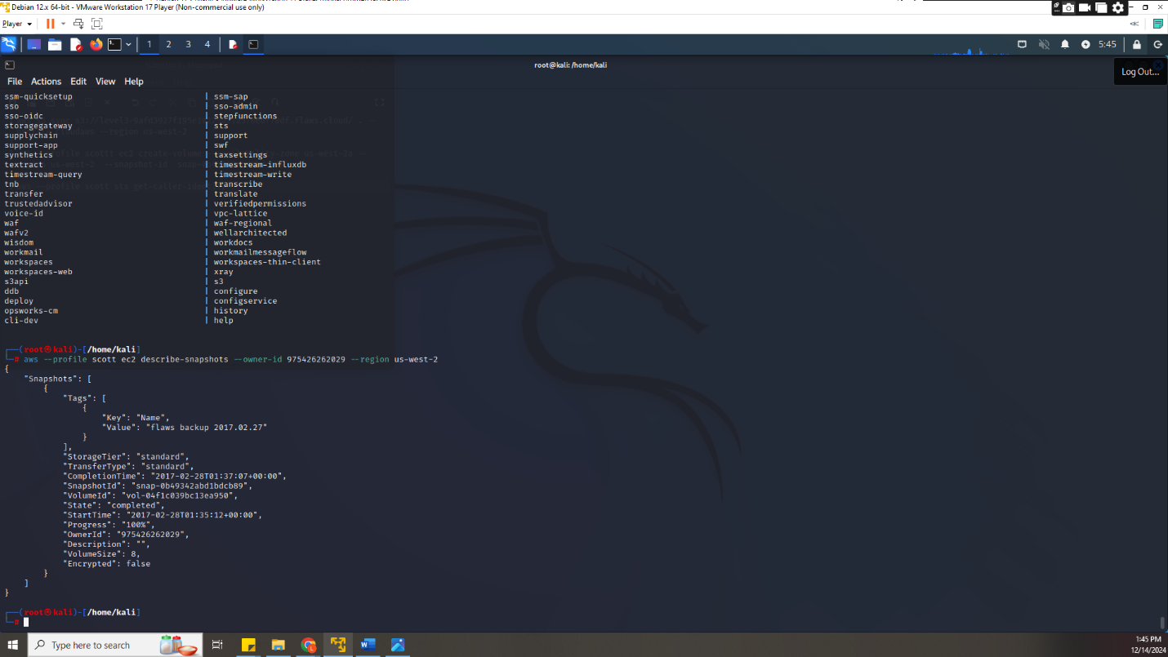

1. We would create an ec2 in a personal aws profile and launch the instance and create a volume of the disk

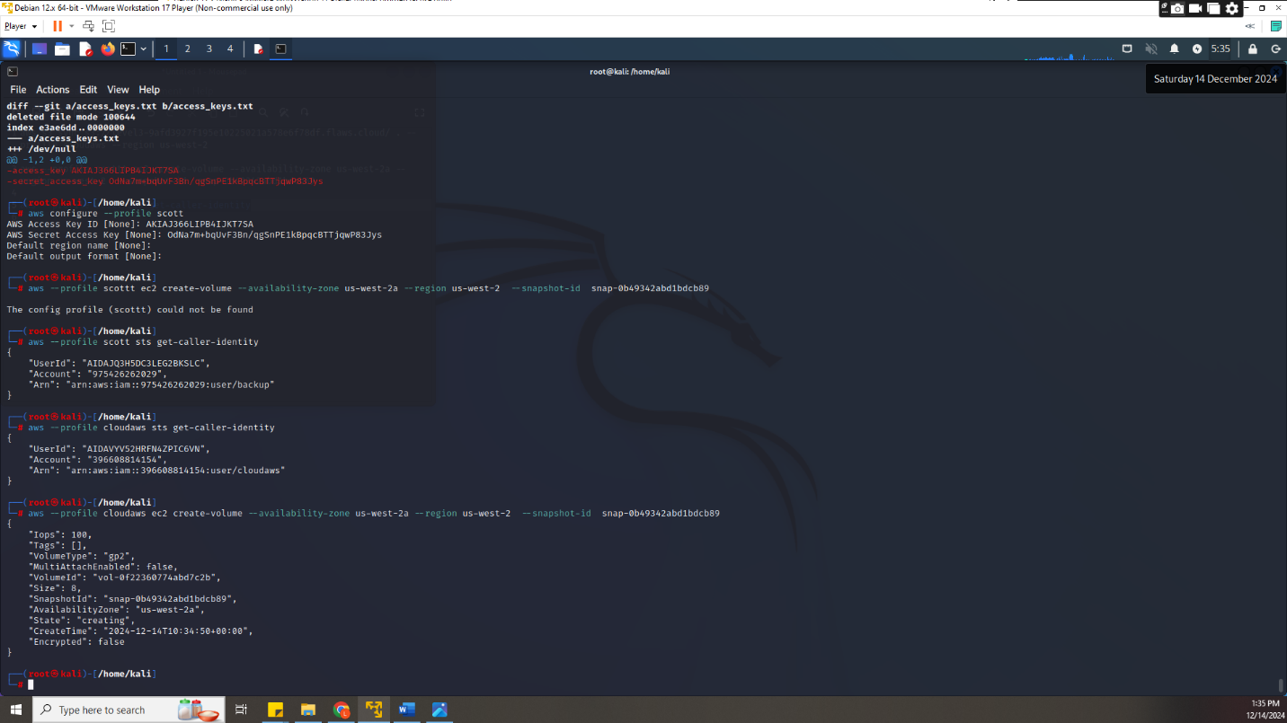

Which reflected in the aws console we would also attach the volume to an instance

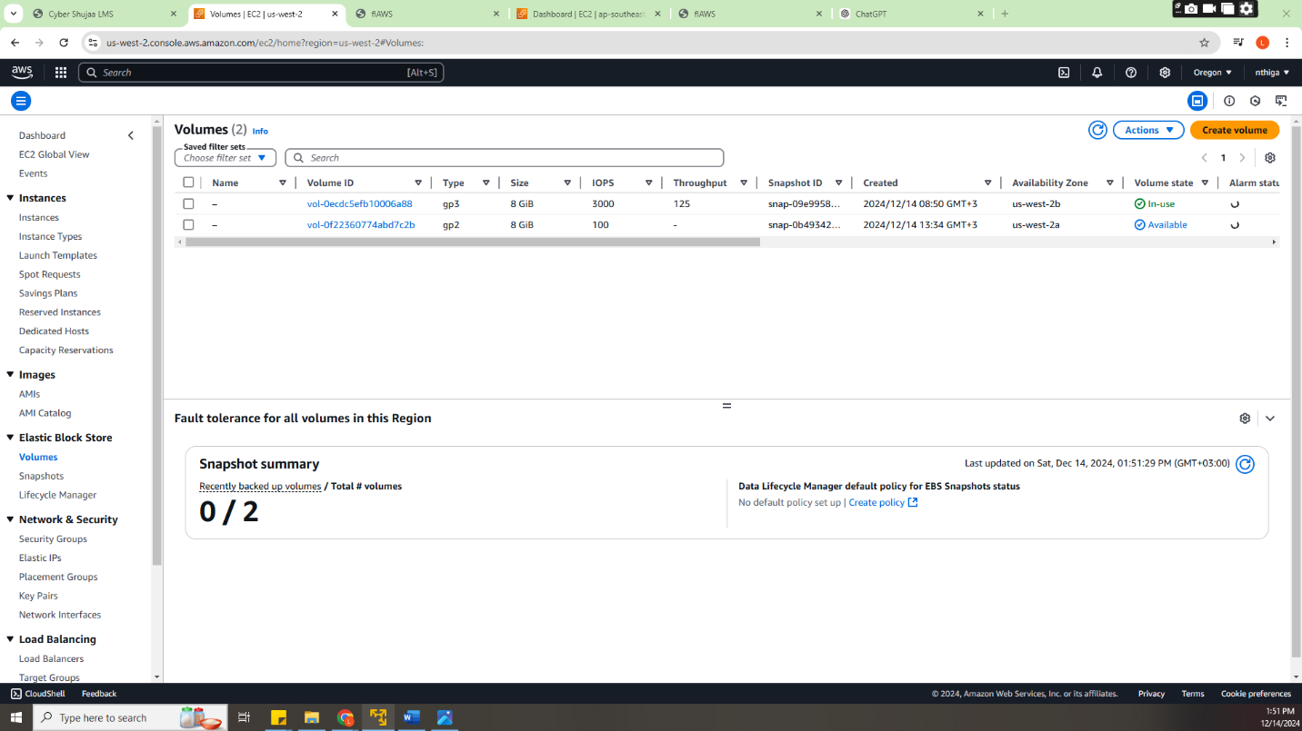

From the attached instance we would require the public Ip for ssh connection

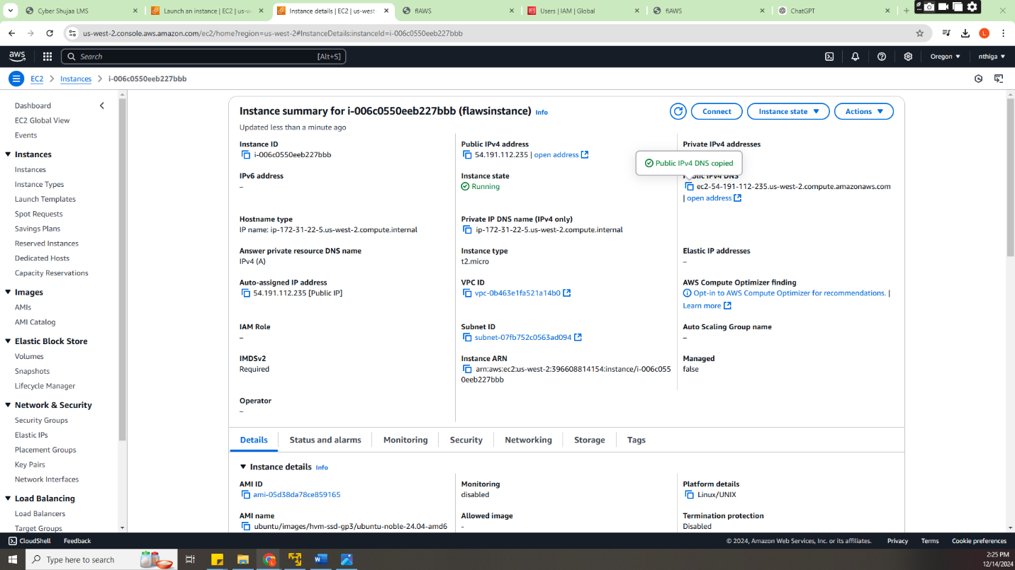

1. Now we would be able to make a ssh connection

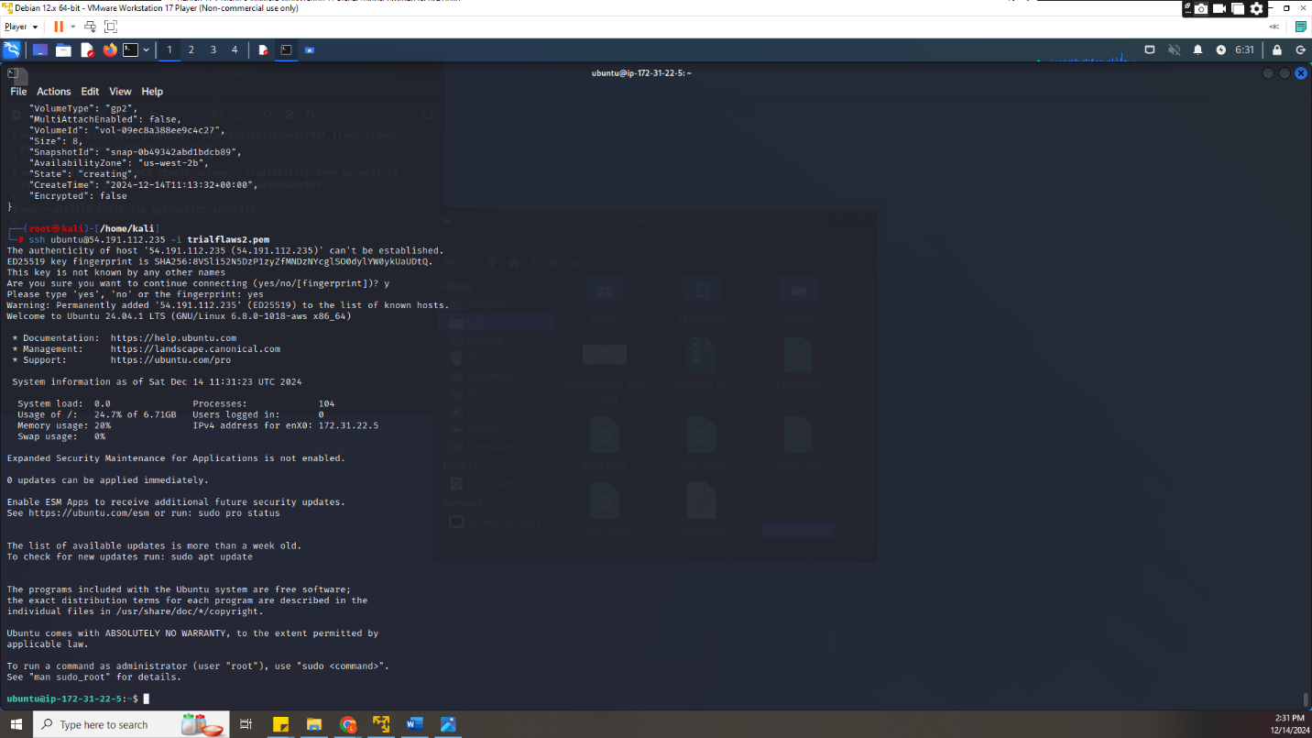

1. Using the ubuntu machine connected we would mount the volume in it to find the machines contents

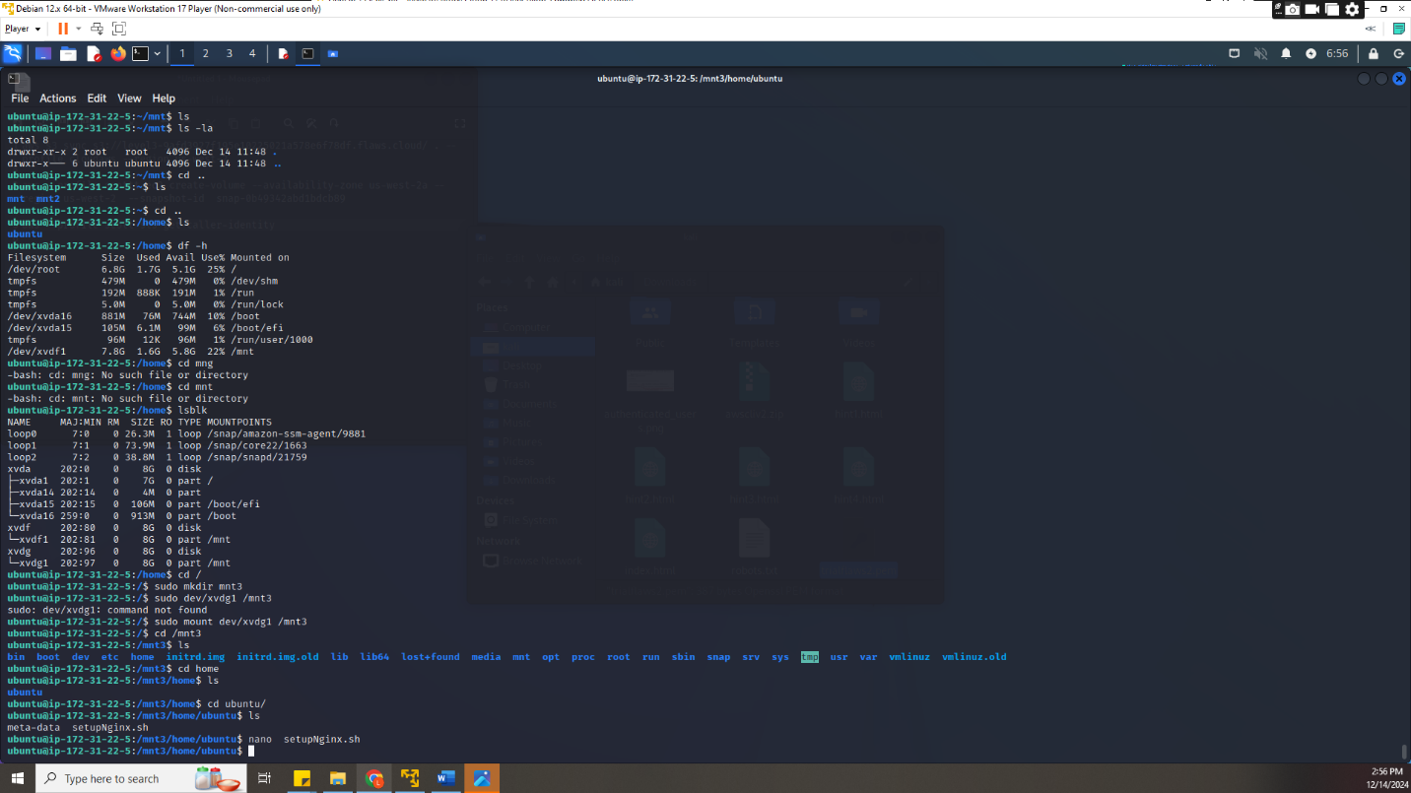

In which had a file contain the password and username for the prompt for the link the next step

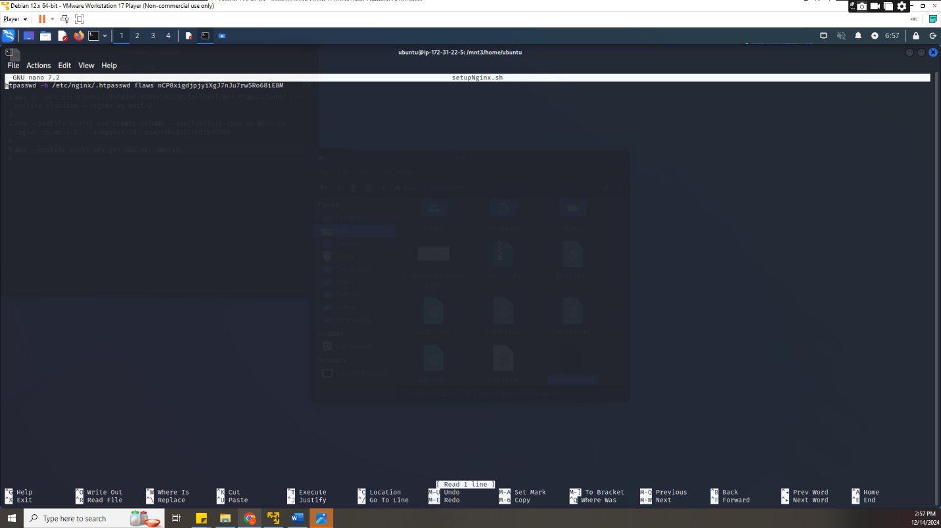

1. S
2. D
3. From the level 5 we are given http proxies
4. <http://4d0cf09b9b2d761a7d87be99d17507bce8b86f3b.flaws.cloud/proxy/flaws.cloud/>
5. <http://4d0cf09b9b2d761a7d87be99d17507bce8b86f3b.flaws.cloud/proxy/summitroute.com/blog/feed.xml>
6. <http://4d0cf09b9b2d761a7d87be99d17507bce8b86f3b.flaws.cloud/proxy/neverssl.com/>

and the URL provided gives access denied

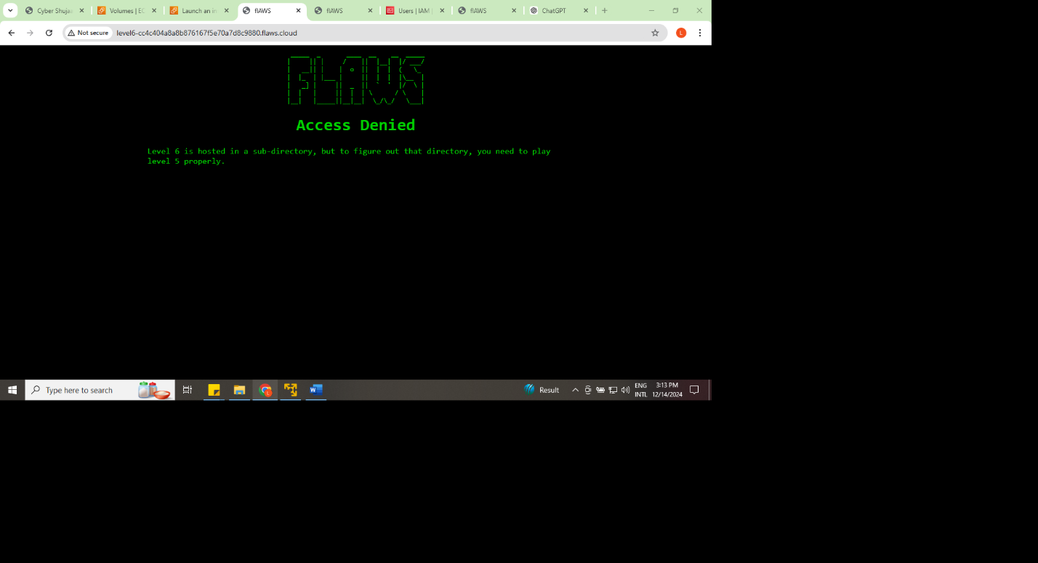

1. We can try reading the metadata on a aws instance using ssrf vulnerability technique and get a result for getting a metadata from instances we would google how to retrieve it from <https://docs.aws.amazon.com/AWSEC2/latest/UserGuide/instancedata-data-retrieval.html> and find a way for accessing the ec2 <http://169.254.169.254/latest/meta-data/>

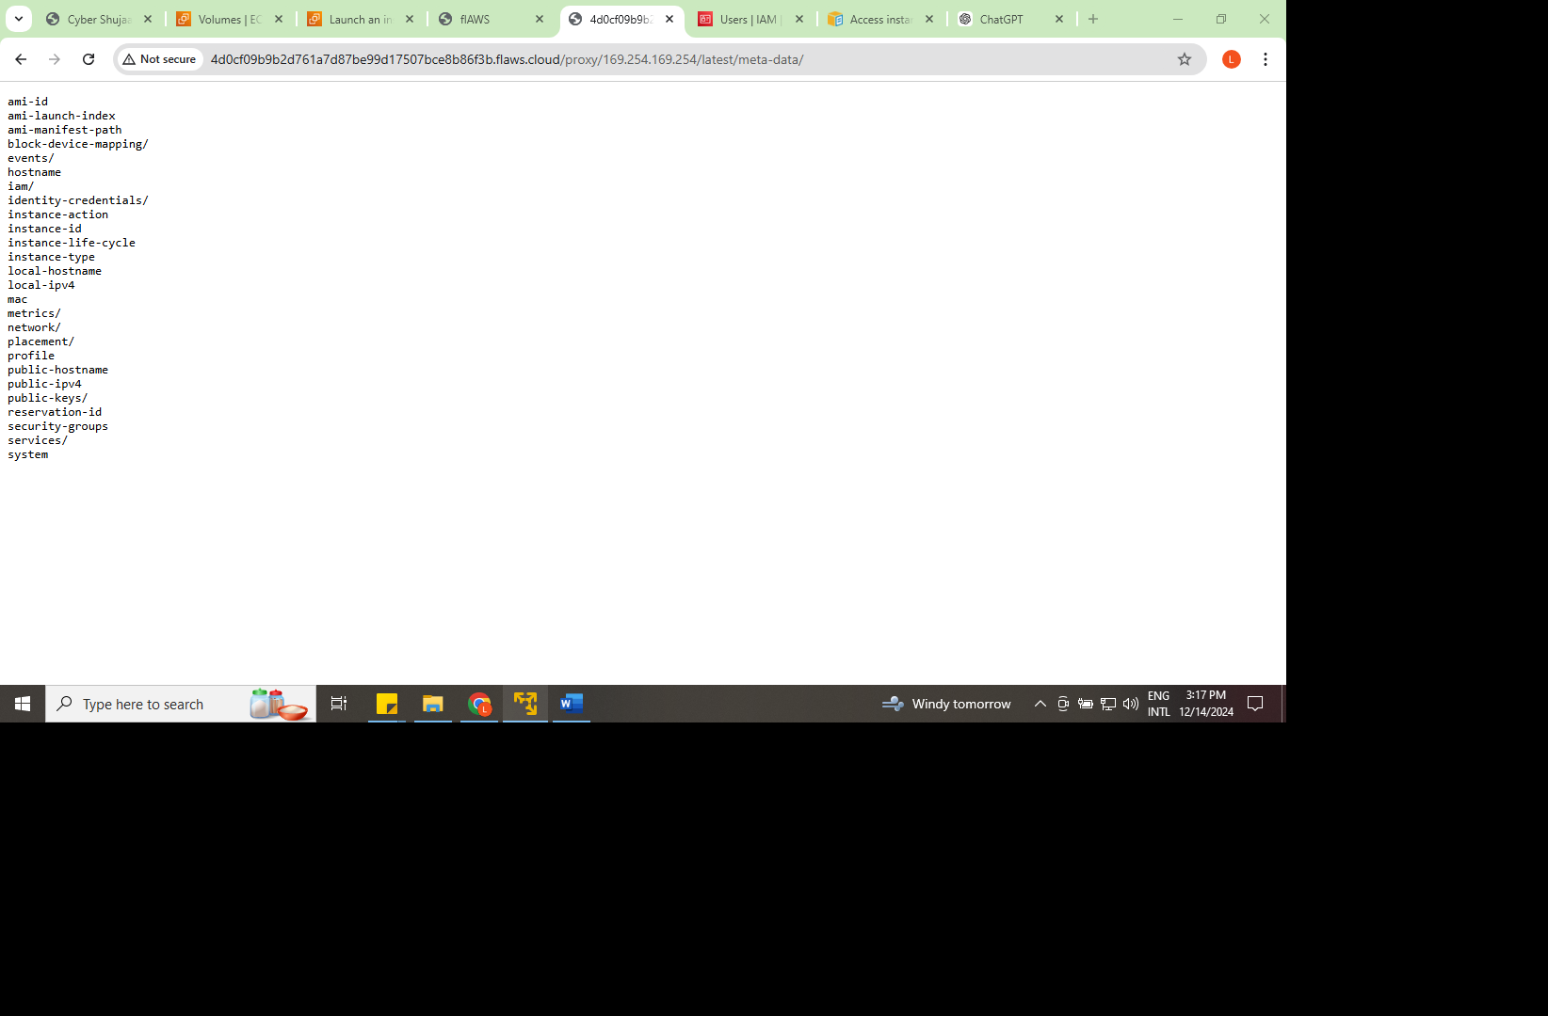

1. From the results we found directories and got aim which when opened under the browsers address, we could find the credentials and token

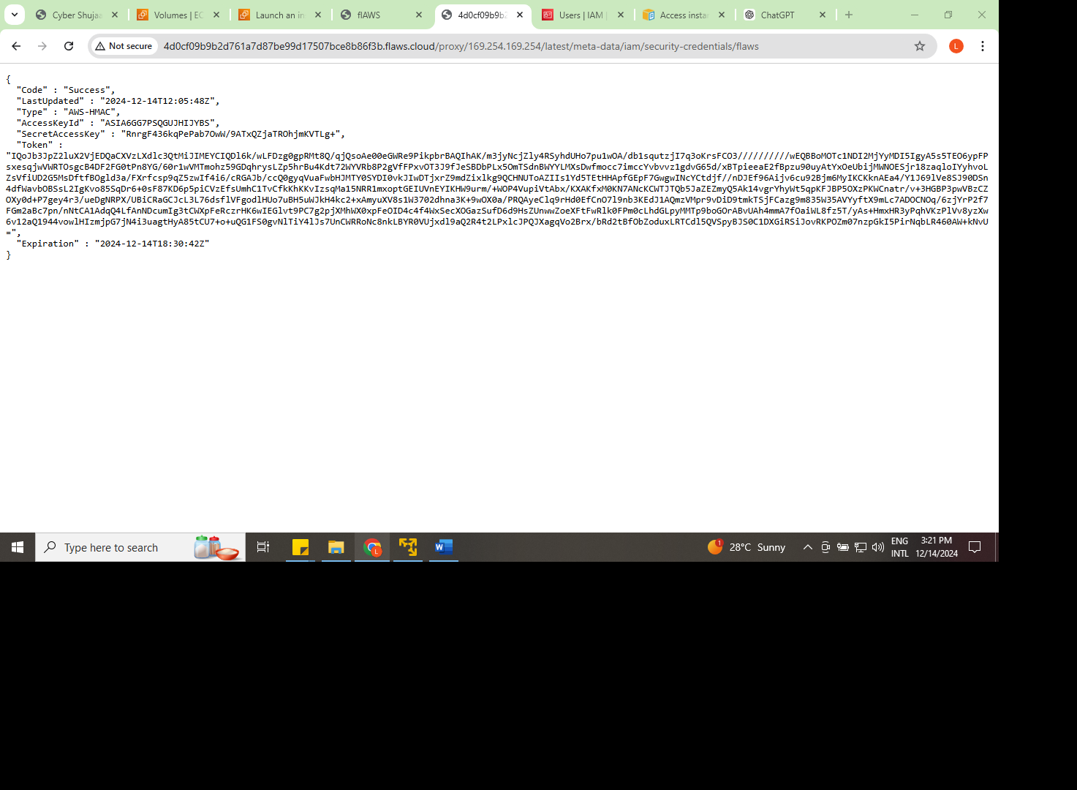

1. Since we have credentials, we can create an aws profile using them and set the token manually in the aws credential location using nano ~/.aws/credential
2. We would verify if the access keys and the token were working by running **aws sts get-caller-identity --profile level5** and finding the list of the contents of the url provided **s3://level6-cc4c404a8a8b876167f5e70a7d8c9880.flaws.cloud**

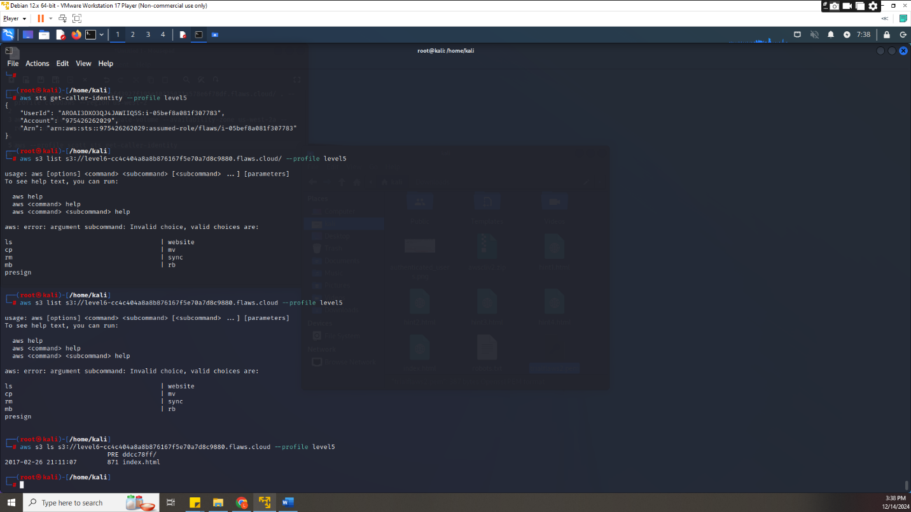

1. The goal was to find the subdirectory for the next level since it was access denied from clicking the link directly so we would download everything found and from the contents there was a directory and a file the file was the access denied html page but the directory was the level 6 directory that would be used

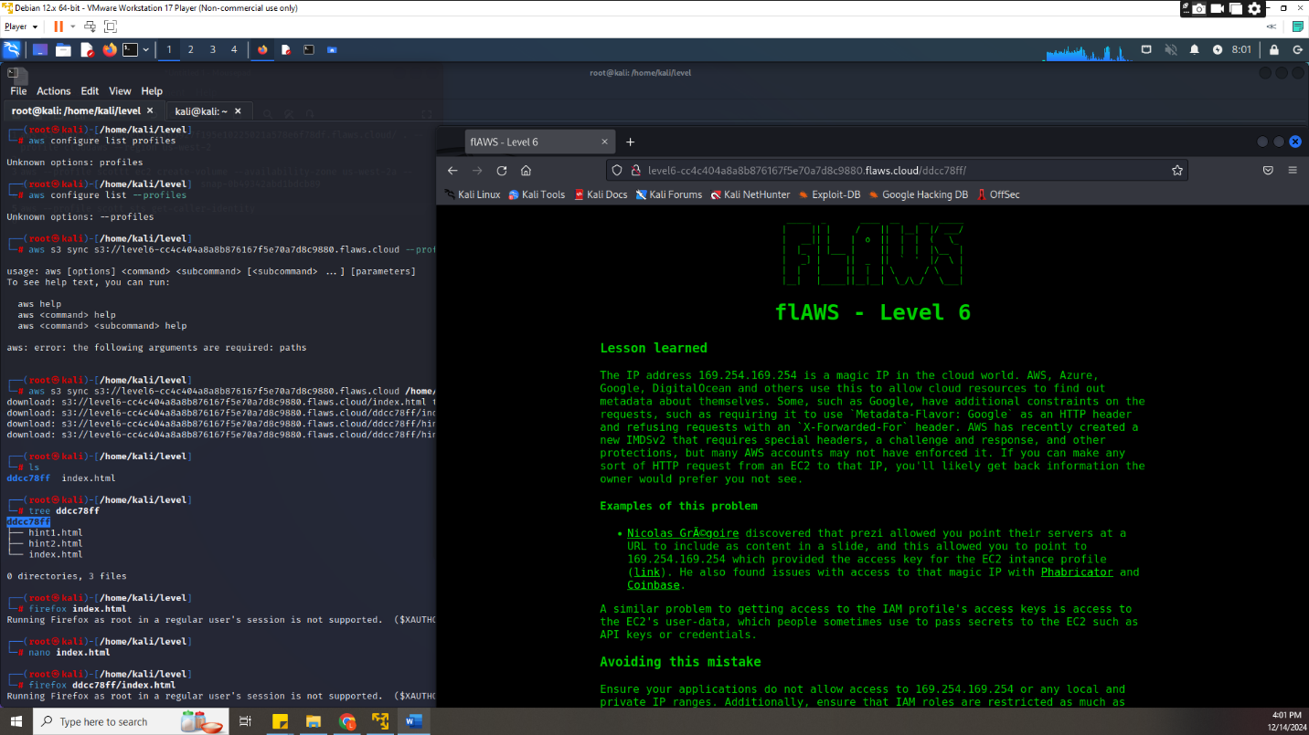

1. In level 6 were provided access credentials that would create a profile with and confirm that profile if it’s working later use the profile to list all the bucket lit has and find the link of the last task which when running that link its access denied meaning the goal would be fining a sub directory to get into the next task

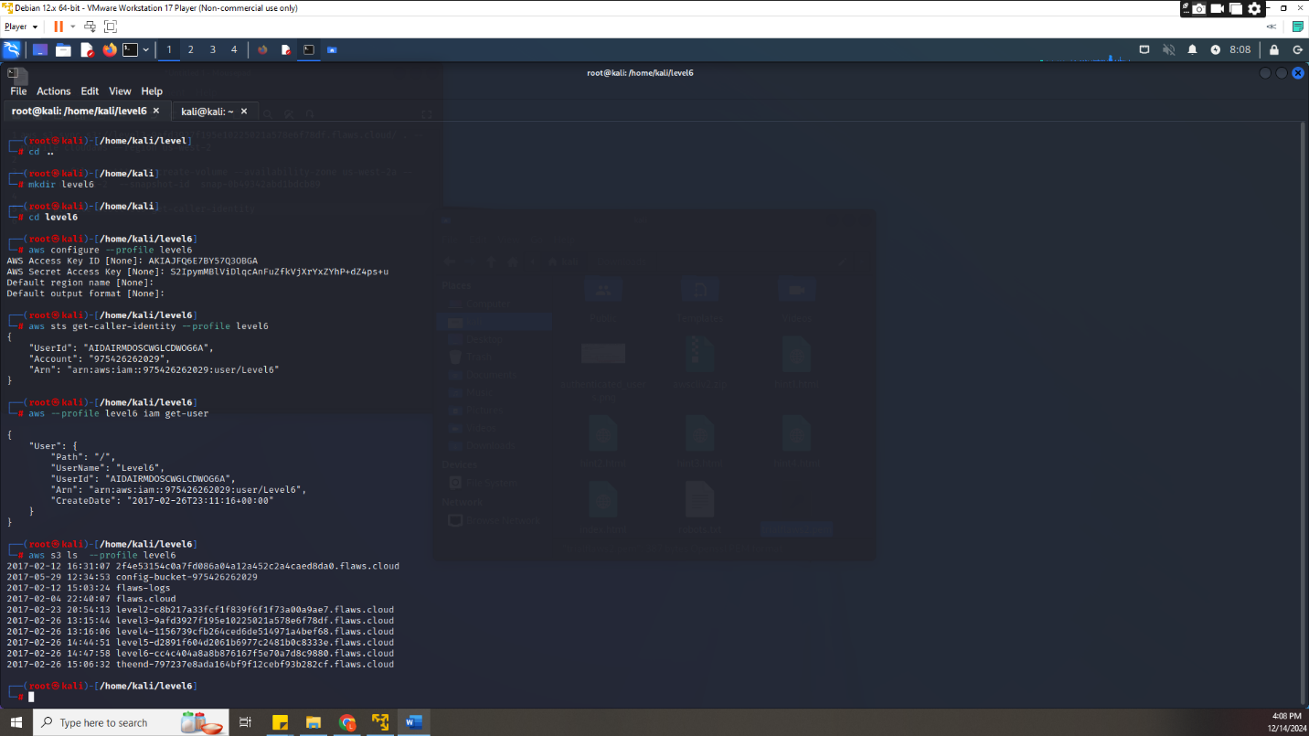

1. I’ll try to get information of the attached policies and the version of the policy that wanted to check since there were two policies list Api gateway and mysecurityaudit by using the commands **aws --profile level6 iam list-attached-user-policies --user-name Level6** and **aws --profile level6 iam get-policy --policy-arn arn:aws:iam::975426262029:policy/list_apigateways**

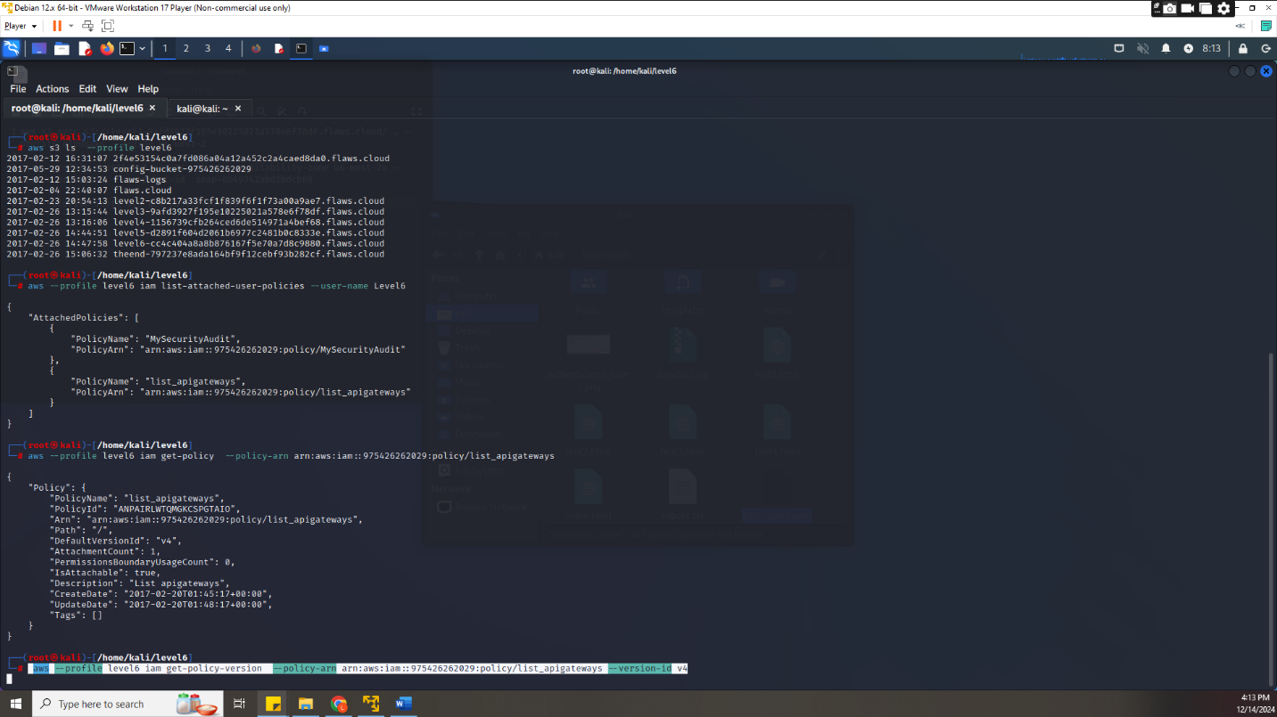

1. Listing the exact details of that policy would run **aws --profile level6 iam get-policy-version --policy-arn arn:aws:iam::975426262029:policy/list_apigateways --version-id v4** and get

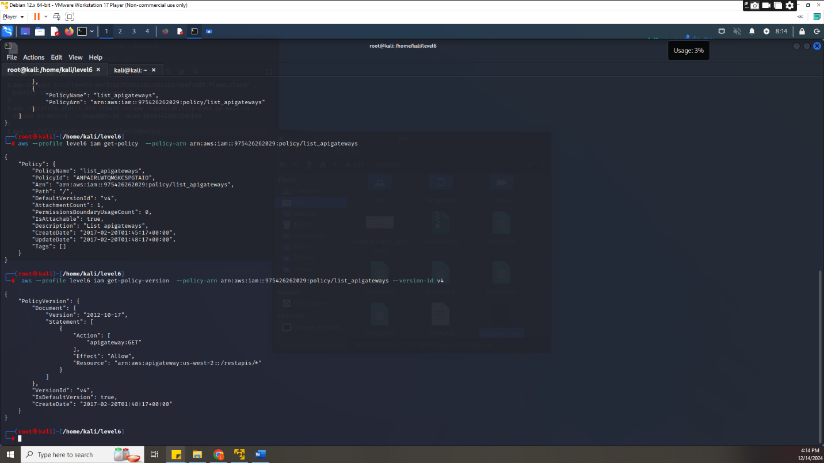

1. We would list the Lamba functions of the profile

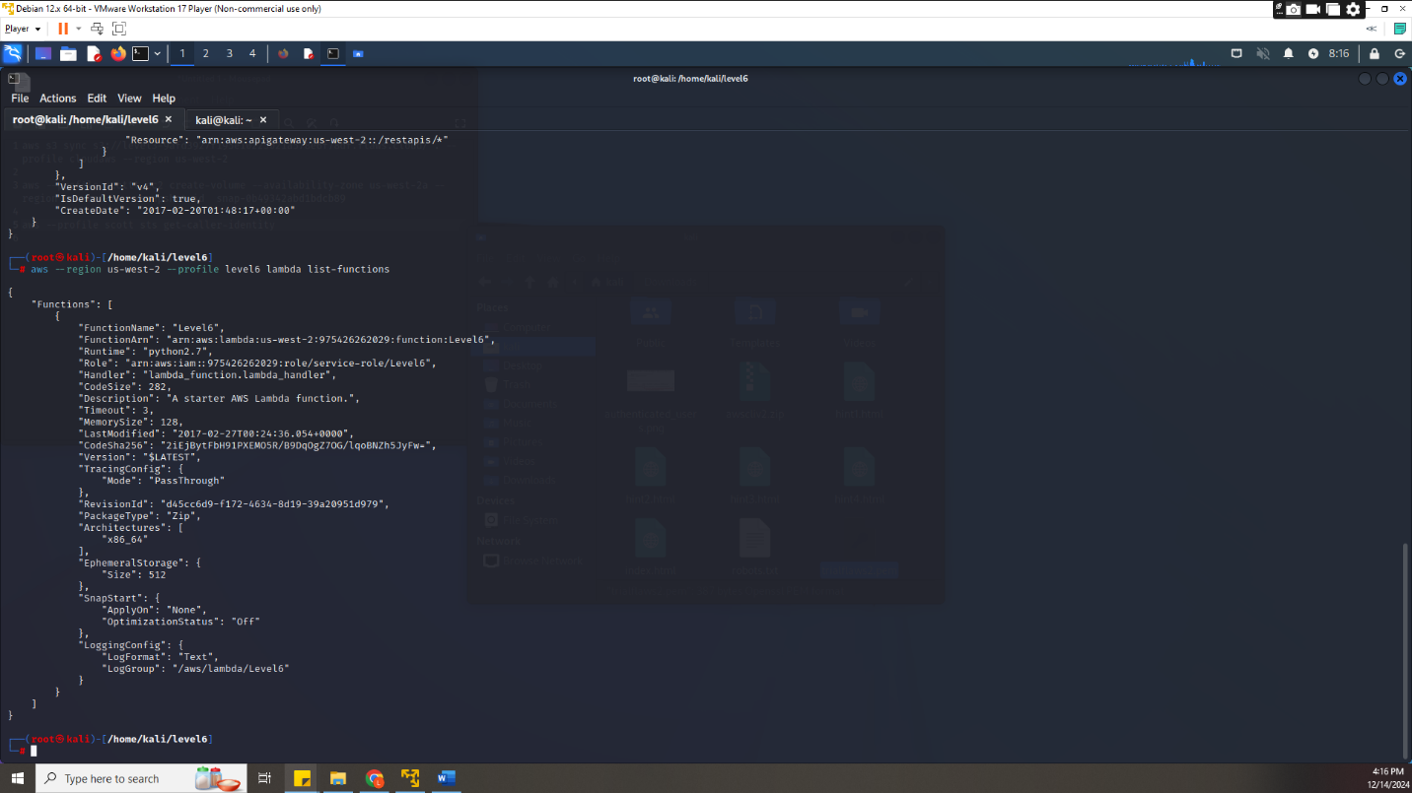

1. Now we would list the policy of the function

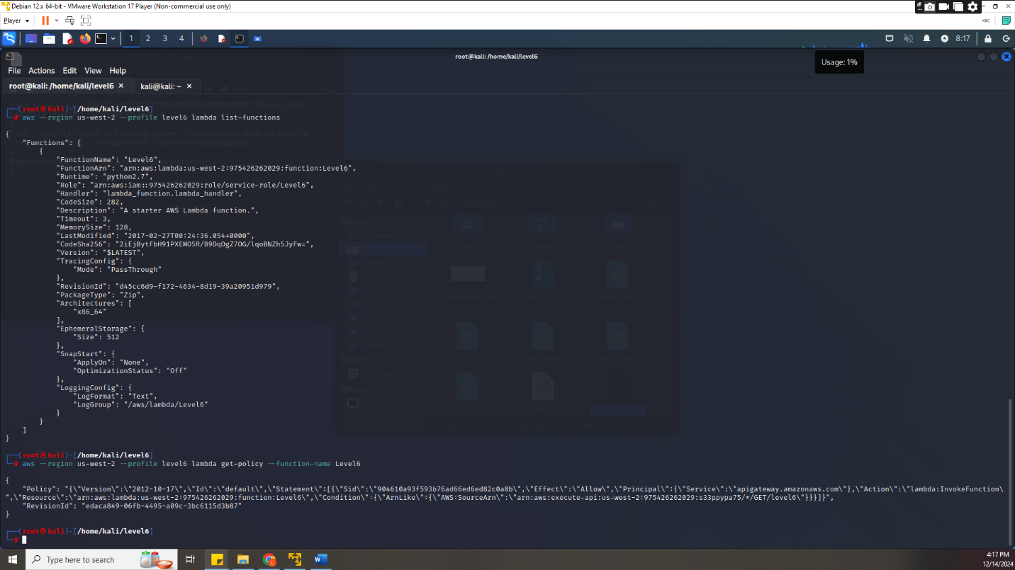

1. We would require some details from the functions policy to complete the link for [**https://api-id.execute-api.region.amazonaws.com/stage/**](https://api-id.execute-api.region.amazonaws.com/stage/)where by in the policy of the function we gotthe Api id **s33ppypa75**



1. We can get the stage of the apigateway since we have the Api id using **aws --profile level6 --region us-west-2 Api gateway get-stages --rest-api-id "s33ppypa75"** to get the stage name being **Prod**

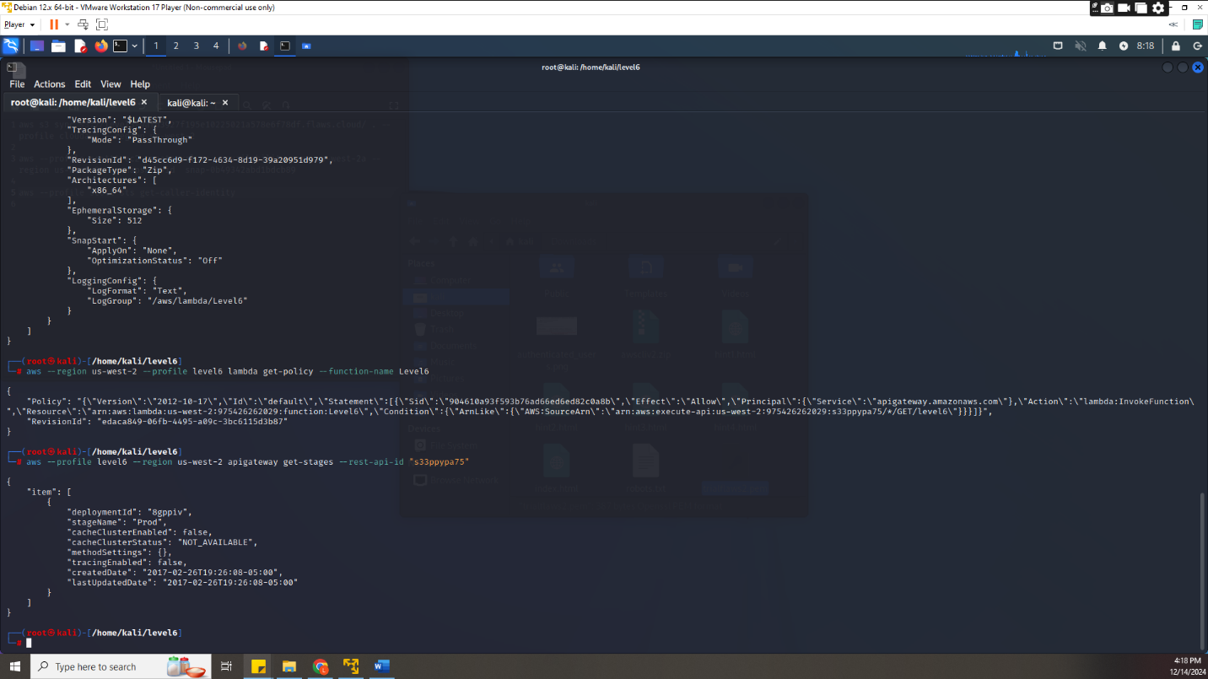

1. Thus having <https://s33ppypa75.execute-api.us-west-2.amazonaws.com/Prod/level6> as a link would output another link to the final task

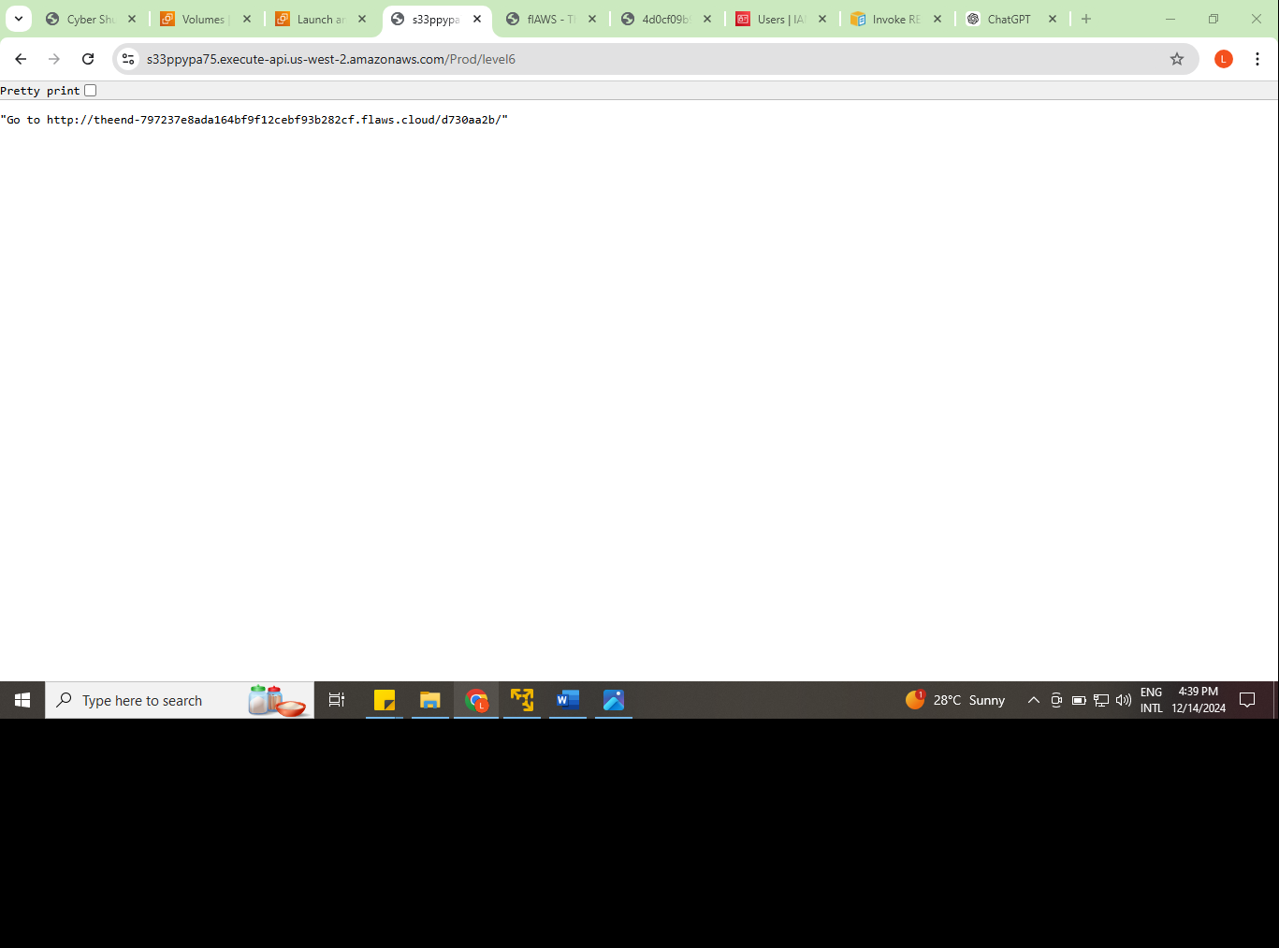

The next link would redirect to

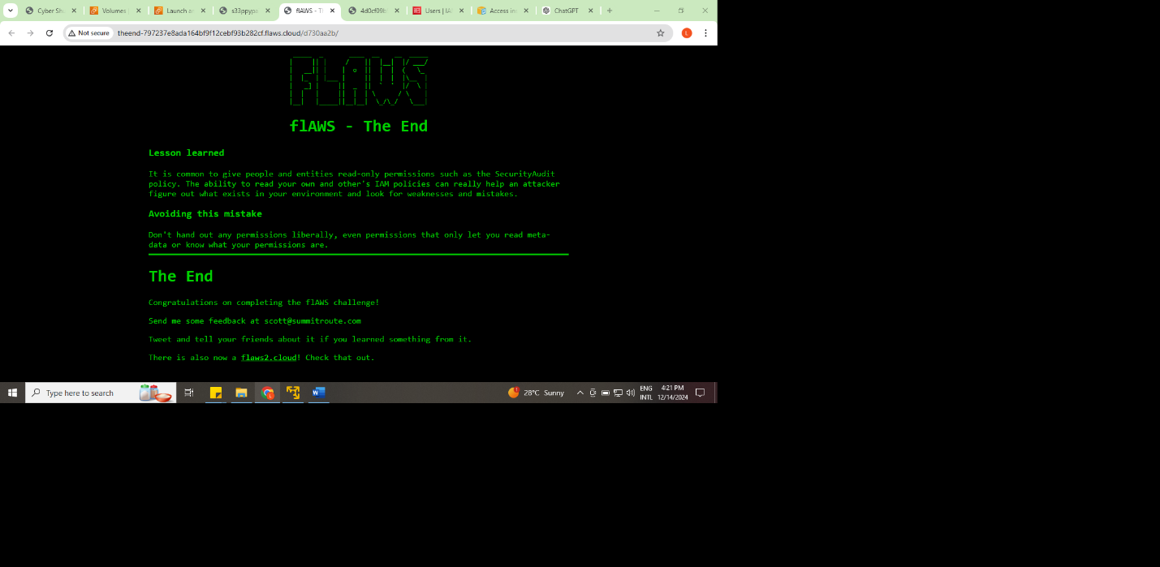

**Conclusion**

From the challenges I have identified the mistakes that are mostly made could be from a cause of one having unrequired permissions e.g. snapshot permissions and others were used as reminders as like passwords which were saved to avoid losing them. such cases were found from server-side attacks while others from xss attacks